Login & Registration Pages

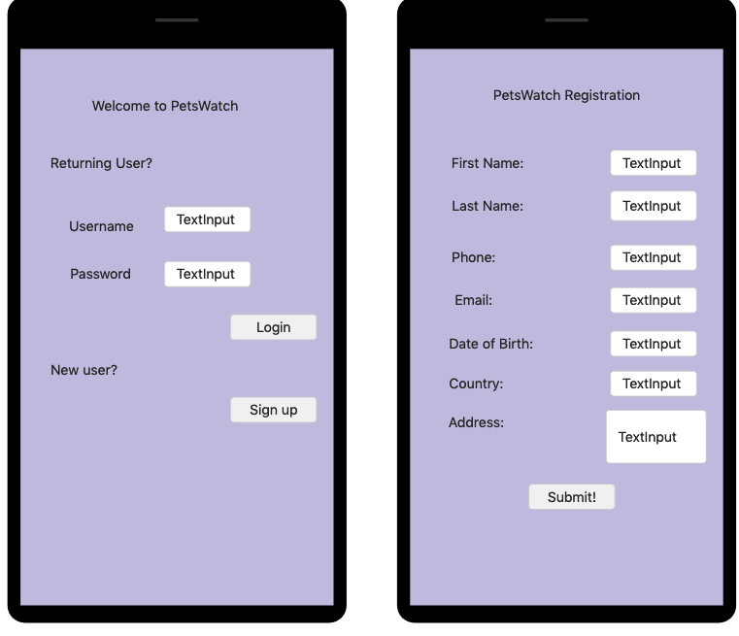

Login pages of the screen mock up. This would be the first page with an input for existing user and a reference to the register page for the new user.

The registration page that includes multiple input fields for new user to create an account for the app.

Preferences Pages

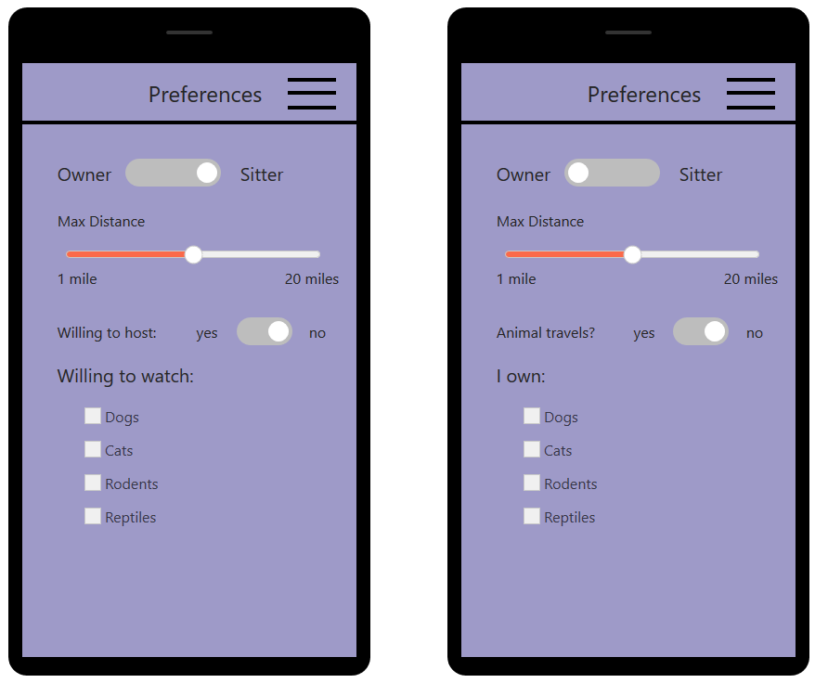

The preferences pages allow for the options the user wishes for. This data would be collected for the owner or sitter’s preferences on the location, the pets, and whether the sitter would host the animal at their house. This would include the main flow in terms of determining the preferences for each account.

Home Page

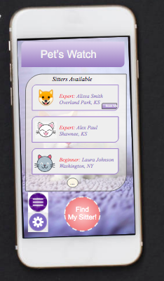

This page, included in the main flow, is what the screen would look like once the user is registered and preferences are set specifically for the owner and would mimic the same interface design for sitters. The listings would display the available sitters.